Project: Dental clinic database.

Course: Database Systems

Instructor:

Msc. Anxhela Baraj

By:

Xhoni Shega,

Marvin Rexhepagaj,

Noelia Karameta,

Laerto Xhuti,

Leandro Pasha.

***1. Enterprise description:***

**a) Give a short description of the enterprise.**

Dental clinic database system involves the development of a database to manage dentist’s information. This system is designed to protect the privacy of the patients. It manages all information about clinics, appointments, patient treatments, products etc. The purpose of the project is to store the data correctly and to reduce the annual work of managing the clinic. It tracks all details about patients, treatments, appointments and invoices.

**b) Describe the functions that the system will perform.**

The goal of this project is to create a database for an existing business, a dental clinic, in the field of medicine for the daily use of the staff. The database will be based on all registrations made in the clinic, all patient treatments and the invoices. The system will display the main page where employees can see all appointments for the day, view all information about patients and all products offered by the clinic, and also book appointments.

**c) Define the end users.**

The end users of this system will be the dentists of the clinic. This system will let the dentists view their appointments, patient’s information and all their treatmetns. Some other end users would be the employees but they will not be able to have a full access to the system as the system was planned to be more for dentists work. The employees can view the products available in the clinic only.

**d) Define the Business Rules based on the above descriptions.**

The clinic sets up a log in form for employees to enter to their profile. An employee ID has one employee, and each employee has only one employee id.

The clinics have their products. So, every clinic has many products, and each product has only one clinic.

When the employees log in, some employees can be dentists. If they are dentists, they can only have only one single emplyee ID.

A dentist is scheduled for many appointments, and each appointment is scheduled with exactly 1 doctor.

A patient scheduels many appointments. Each appointment is scheduled by one patient.

A patient makes many patient treatments, and each patient treatment is made for one patient.

One treatment has many patient treatments, and each patient treatment can have only one treatment.

Many treatments can have one or zero prescription, and each percription can have many treatments or zero.

A treatments generates many invoice treatments, and each invoice treatment is generated by only one treatment.

Many invoice treatments apply only one invoice, and a single invoice applies many invoice treatments.

***2. Technical description.***

**Describe all the technologies used.**

There were several requirements for the project. First, the final product must be available on a Windows PC, as this is the default operating system used by the team members. Second, it must be fully compatible with desktop and smartphone so that the website can be accessed by employees with different devices.

The software/applications used by the team are:

Draw - ERD

Netbeans - Java

GUI

SQLServer - database implementation

Draw.io – normalization

***3.Entity Relationship Design:***

**a) Describe your entities. Define the strong and weak entities:**

**Product:** Product is a strong entity which contains all the necessary information about products that are needed for the clinic in order to be operational. The PRODUCT_ID is the primary key for this entity.

**Clinic:** Clinic is a strong entity which contains the information about the clinic like the address, phone number, etc. The primary key for this entity is CLINIC_ID.

**Employee:** Employee is a strong entity which contains all the required information about the employee of the clinic. The primary key for this entity is EMPLOYEE_ID. Th

**Login_Employee:** Login_Employee is a weak entity which contains the information about login credentials that an employee needs to have in order to have certain access to the system. The primary of this entity is a composed primary key composed of EMPLOYEE_USERNAME and EMPLOYEE_ID.

**Dentist:** Dentist is a strong entity which contains the information about the dentist the role of the dentist on the clinic. The primary key for this entity is DENTIST_ID.

**Appointment:** Appointment is a strong entity which contains the necessary information about an appointment. The primary key for this entity is Appointment_ID.

**Patient:** Patient is a strong entity which contains the necessary information about the patient. The primary for this entity is PATIENT_PERSONAL_NUMBER.

**Patient_Treatment:** Patient_Treatment is a weak entity which serves as a table for the connection of the patient with the treatment. The primary key on this entity is composed of PATIENT_PERSONAL_NUMBER and TREATMENT_ID.

**Treatment:** Treatment is a strong entity which contains the information about the treatment. The primary key for this entity is TREATMENT_ID.

**Perscription:** Perscription is a weak entity which is existence is dependent on the treatment that the patient will take. The primary key for this entity is composed of PERSCRIPTION_ID and TREATMENT_ID.

**Invoice_Treatment:** Invoice_Treatment is a weak entity which is existence dependent on the invoice table and treatment table. The primary key is composed of INVOICE_ID and TREATMENT_ID.

**Invoice:** Invoice is a strong entity which contains the information about the invoice. The primary key of this entity is INVOICE_ID.

**b) Describe the relationships between tables and their types.**

Clinic table is related with the product table, the type of the relationship is one-to-many where the entity product is the many part of the relationship and the table clinic is the one part of the relationship, the foreign key is CLINIC_ID;

Clinic is also related with the Employee table, the type of the relationship is one-to-many to many relationship where the entity employee is the many part of the relationship and the entity clinic is the one part of the relationship, the foreign key is CLINIC_ID;

Employee table is related with Login_Employee table, the type of the relationship is one-to-one relationship, the foreign key is stored in Login_Employee table since it is a weak entity and is existence dependent on the employee table, it is EMPLOYEE_ID;

Employee is also related with the table dentist on a one-to-one relationship optional which means the an employee of the clinic optionally can be a dentist. The foreign key is stored on the dentist table and it is EMPLOYEE_ID;

Dentist table is related with appointment table on a one-to-many relationship, where the Dentist is the one part of the relationship and the appointment is the many part of the relationship, the foreign key is stored on appointment table and it is DENTIST_ID;

Appointment table is related with the patient table on a one-to-many relationship where patient is the one part of the relationship and the appointment is the many part of the relationship where the foreign key is stored which is, PATIENT_PERSONAL_NUMBER;

Patient table is related with the treatment table on a many-to-many relationship which is broken on two one-to-many relationship by using the table patient_treatment.

Treatment table is also related with the prescription table on a one-to-one relationship optional where the foreign key is stored on the prescription table since it is a weak entity existence dependent on the treatment table.

Treatment table is also related with the invoice table on a many-to-many relationship which is broken down on two one-to-many relationships by using the table invoice_treatment.

**c) Draw the Crow’s Foot ER Diagram for your database.**

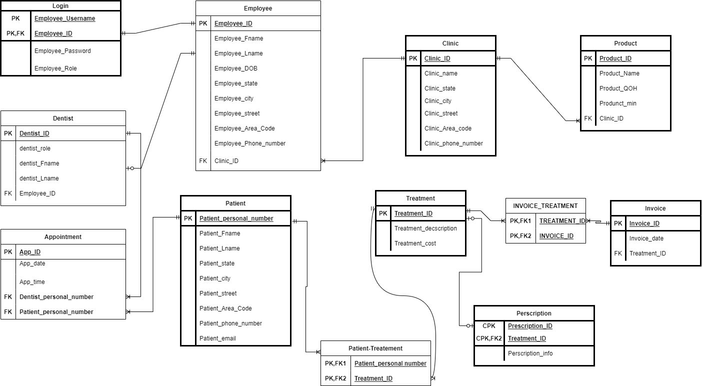

**In the project file will also provide a xml file which can open the diagram on draw.io**

***4.*** ***4. Normalization:***

**Each base table MUST be in 3NF and must have the following information associated with it:**

**a) The Primary Keys.**

**b) A list of Foreign Keys.**

**c) A list of and functional dependencies that hold.**

UNF:

Clinic(clinic_id, clinic_state, clinic_city, clinic_are_code, clinic_phone_number);

Product(product_name, product_QOH, Product_min);

Dentist(Dentist_id, dentist_role, employee_id, employee_f_name, employee_l_name, employee_DOB, employee_state, employee_city, employee_street, employee_area_code, employee_phone_number);

Appointment(Appointment_ID, appointment_time);

Patient_Treatment(Patient_personal_number, Patient_fname, Patient_lname, Patient_state, Patient_city, Patient_street, Patient_area_code, Patient_phone_number, Patient_email, Treatement_id, Treatment_description, Treatment_cost);

Invoice_Treatment(Treatment_id, Treatment_description, Treatment_cost, Invoice_id, invoice_date);

Perscription(Perscription_id, Treatment_id, prescription_info);

1NF:

Clinic(**clinic_id**, clinic_state, clinic_city,clinic_street, clinic_are_code, clinic_phone_number);

Product(**product_id**,product_name, product_QOH, Product_min, product_reorder,***clinic_id***);

Dentist(**Dentist_id**, dentist_role, **employee_id**, employee_f_name, employee_l_name, employee_DOB, employee_state, employee_city, employee_street, employee_area_code, employee_phone_number);

Appointment(**Appointment_ID**, appointment_time,***Dentist_id***, ***Patient_personal_number***);

Patient_Treatment(**Patient_personal_number**, Patient_fname, Patient_lname, Patient_state, Patient_city, Patient_street, Patient_area_code, Patient_phone_number, Patient_email, **Treatement_id**, Treatment_description, Treatment_cost);

Invoice_treatment(**Invoice_id, Treatment_id**)

Invoice(**Invoice_id**, invoice_date);

Perscription(**Perscription_id**, ***Treatment_id***, prescription_info);

We have partial dependencies between:

Employee_id 🡪 employee_f_name, employee_l_name, employee_DOB, employee_state, employee_city, employee_street, employee_area_code, employee_phone_number;

Dentist_id 🡪 Dentist_role, Employee_id;

Patient_personal_number 🡪 Patient_fname, Patient_lname, Patient_state, Patient_city, Patient_street, Patient_area_code, Patient_phone_number, Patient_email;

**Treatement_id**🡪 Treatment_description, Treatment_cost;

2NF and 3NF

We break the partial dependencies and we have:

Clinic(**clinic_id**, clinic_state, clinic_city,clinic_street, clinic_are_code, clinic_phone_number);

Product(**product_id**,product_name, product_QOH, Product_min, product_reorder,***clinic_id***);

Dentist(**Dentist_id**, dentist_role);

Employee(, **employee_id**, employee_f_name, employee_l_name, employee_DOB, employee_state, employee_city, employee_street, employee_area_code, employee_phone_number);

Appointment(**Appointment_ID**, appointment_time,***Dentist_id***, ***Patient_personal_number***);

Patient_Treatment(**Patient_personal_number**, **Treatement_id**);

Patient(**Patient_personal_number**, Patient_fname, Patient_lname, Patient_state, Patient_city, Patient_street, Patient_area_code, Patient_phone_number, Patient_email,)

Treatment(**Treatement_id**, Treatment_description, Treatment_cost)

Invoice_treatment(**Invoice_id, Treatment_id**)

Invoice(**Invoice_id**, invoice_date);

Perscription(**Perscription_id**, ***Treatment_id***, prescription_info);

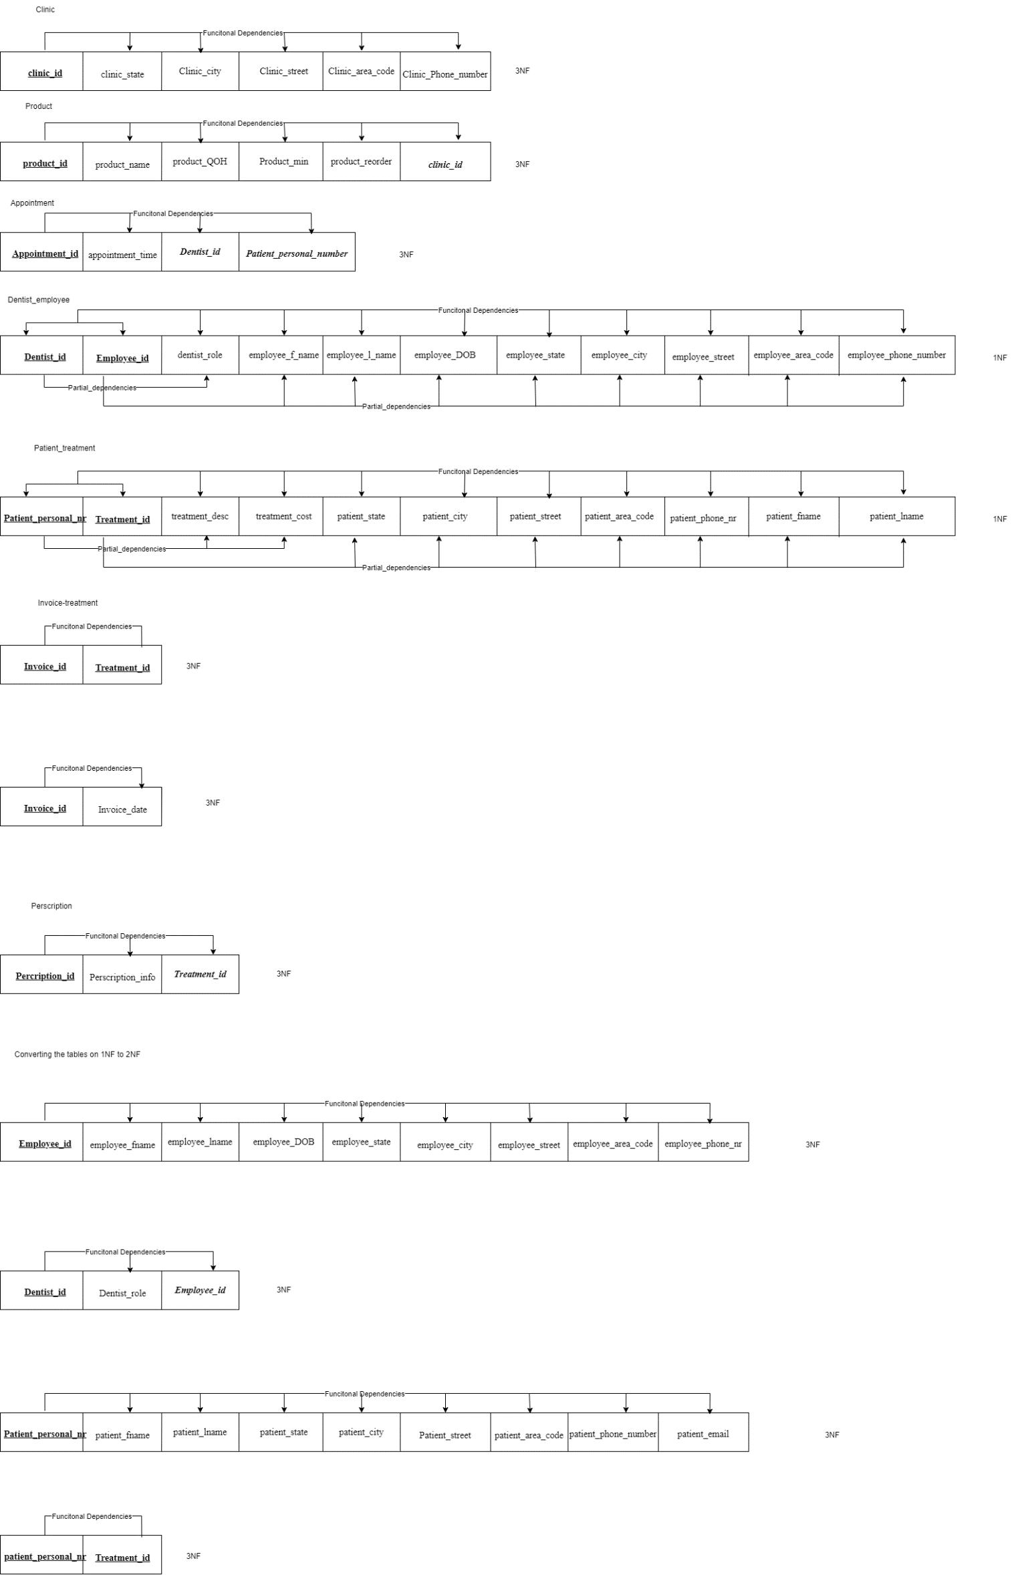

***5. Data Dictionary:***



***It is also found as an excel spreadsheet on the folder of the project***

***6. Implement your tables in SQL SERVER Management Studio or any RDBMS you***

***are familiar to.***

CREATE DATABASE DENTAL_CLINIC;

CREATE TABLE CLINIC(

CLINIC_ID INTEGER NOT NULL,

CLINIC_NAME VARCHAR(50) NOT NULL,

CLINIC_STATE VARCHAR(20) NOT NULL,

CLINIC_CITY VARCHAR(20) NOT NULL,

CLINIC_STREET VARCHAR(20) NOT NULL,

CLINIC_AREA_CODE INTEGER NOT NULL,

CLINIC_PHONE_NUMBER INTEGER NOT NULL,

PRIMARY KEY(CLINIC_ID)

); --End of table clinic

CREATE TABLE PRODUCT(

PRODUCT_ID INTEGER NOT NULL,

PRODUCT_NAME VARCHAR(50) NOT NULL,

PRODUCT_QOH INTEGER NOT NULL,

PRODUCT_MIN INTEGER NOT NULL,

PRODUCT_REORDER INTEGER NOT NULL,

CLINIC_ID INTEGER NOT NULL,

PRIMARY KEY(PRODUCT_ID),

FOREIGN KEY (CLINIC_ID) REFERENCES CLINIC

);

CREATE TABLE EMPLOYEE(

EMPLOYEE_ID INTEGER IDENTITY(1,1),

EMPLOYEE_F_NAME VARCHAR(50) NOT NULL,

EMPLOYEE_L_NAME VARCHAR (50) NOT NULL,

EMPLOYEE_DOB DATE NOT NULL,

EMPLOYEE_STATE VARCHAR(20) NOT NULL,

EMPOYEE_CITY VARCHAR(20) NOT NULL,

EMPLOYEE_STREET VARCHAR(20) NOT NULL,

EMPLOYEE_AREA_CODE INTEGER NOT NULL,

EMPLOYEE_PHONE_NUMBER INTEGER NOT NULL,

CLINIC_ID INTEGER NOT NULL,

PRIMARY KEY(EMPLOYEE_ID),

FOREIGN KEY(CLINIC_ID) REFERENCES CLINIC

); --End of table employee

CREATE TABLE LOGIN_EMPLOYEE(

EMPLOYEE_USERNAME VARCHAR(50) NOT NULL,

EMPLOYEE_ID INTEGER NOT NULL,

EMPLOYEE_PASSWORD VARCHAR(30) NOT NULL,

EMPLOYEE_ROLE VARCHAR(20) NOT NULL,

PRIMARY KEY(EMPLOYEE_USERNAME, EMPLOYEE_ID),

FOREIGN KEY(EMPLOYEE_ID) REFERENCES EMPLOYEE

ON DELETE CASCADE

); --End of table login

CREATE TABLE DENTIST(

DENTIST_ID INTEGER IDENTITY(1,1),

DENTIST_ROLE VARCHAR NOT NULL,

EMPLOYEE_ID INTEGER ,

PRIMARY KEY(DENTIST_ID),

FOREIGN KEY(EMPLOYEE_ID) REFERENCES EMPLOYEE

);--End of table dentist

CREATE TABLE PATIENT(

PATIENT_PERSONAL_NUMBER INTEGER NOT NULL,

PATIENT_FIRST_NAME VARCHAR(50),

PATIENT_LAST_NAME VARCHAR(50),

PATIENT_STATE VARCHAR(20) NOT NULL,

PATIENT_CITY VARCHAR(20) NOT NULL,

PATIENT_STREET VARCHAR(20) NOT NULL,

PATIENT_AREA_CODE INTEGER NOT NULL,

PATIENT_PHONE_NUMBER INTEGER NOT NULL,

PATIENT_EMAIL VARCHAR(50),

PRIMARY KEY (PATIENT_PERSONAL_NUMBER)

);--End of table patient

CREATE TABLE APPOINTMENT(

APPOINTMENT_ID INTEGER IDENTITY(1,1),

APPOINTMENT_TIME DATE NOT NULL,

DENTIST_ID INTEGER NOT NULL,

PATIENT_PERSONAL_NUMBER INTEGER NOT NULL,

PRIMARY KEY(APPOINTMENT_ID),

FOREIGN KEY(DENTIST_ID) REFERENCES DENTIST,

FOREIGN KEY(PATIENT_PERSONAL_NUMBER) REFERENCES PATIENT

);--End of table appointment

CREATE TABLE TREATMENT(

TREATMENT_ID INTEGER IDENTITY(1,1),

TREATMENT_DESCRIPTION VARCHAR(100) NOT NULL,

TREATMENT_COST INTEGER NOT NULL,

PRIMARY KEY(TREATMENT_ID)

); --End of table treatment

CREATE TABLE PATIENT_TREATMENT(

PATIENT_PERSONAL_NUMBER INTEGER NOT NULL,

TREATMENT_ID INTEGER NOT NULL,

PRIMARY KEY(PATIENT_PERSONAL_NUMBER, TREATMENT_ID),

FOREIGN KEY (PATIENT_PERSONAL_NUMBER) REFERENCES PATIENT,

FOREIGN KEY(TREATMENT_ID) REFERENCES TREATMENT

ON DELETE CASCADE

); --End of table patient_treatment

CREATE TABLE PRESCRIPTION(

PRESCRIPTION_ID INTEGER IDENTITY(1,1),

TREATMENT_ID INTEGER,

PRESCRIPTION_INFO VARCHAR(200),

PRIMARY KEY(PRESCRIPTION_ID, TREATMENT_ID),

FOREIGN KEY (TREATMENT_ID) REFERENCES TREATMENT

ON DELETE CASCADE

);

CREATE TABLE INVOICE(

INVOICE_ID INTEGER IDENTITY(1,1),

INVOICE_DATE DATE NOT NULL,

PRIMARY KEY(INVOICE_ID)

);

CREATE TABLE INVOICE_TREATMENT(

INVOICE_ID INTEGER NOT NULL,

TREATMENT_ID INTEGER NOT NULL,

PRIMARY KEY(INVOICE_ID, TREATMENT_ID),

FOREIGN KEY(INVOICE_ID) REFERENCES INVOICE,

FOREIGN KEY(TREATMENT_ID) REFERENCES TREATMENT

ON DELETE CASCADE

);

***7. Build a set of queries that must include:***

**CLINIC:**

string query = @"SELECT * FROM CLINIC";

string query = @"INSERT INTO CLINIC VALUES(

'" + clinic.ClinicName + @"'

,'" + clinic.ClinicState + @"'

,'" + clinic.ClinicCity + @"'

,'" + clinic.ClinicStreet + @"'

,'" + clinic.ClinicAreaCode + @"'

,'" + clinic.ClinicPhoneNumber + @"')";

string query = @"UPDATE CLINIC SET

CLINIC_NAME='"+clinic.ClinicName+@"',

CLINIC_STATE='"+clinic.ClinicState+ @"',

CLINIC_CITY='"+clinic.ClinicCity+ @"',

CLINIC_STREET='" + clinic.ClinicStreet + @"',

CLINIC_AREA_CODE='" + clinic.ClinicAreaCode + @"',

CLINIC_PHONE_NUMBER='" + clinic.ClinicPhoneNumber + @"'

WHERE CLINIC_ID="+clinic.ClinicId+@"";

string query = @"DELETE FROM CLINIC WHERE CLINIC_ID="+id+@"";

**EMPLOYEE:**

string query = @"SELECT * FROM EMPLOYEE FULL OUTER JOIN LOGIN_EMPLOYEE ON EMPLOYEE.EMPLOYEE_ID = LOGIN_EMPLOYEE.EMPLOYEE_ID";

string query = @"INSERT INTO [dbo].[EMPLOYEE]

([EMPLOYEE_F_NAME]

,[EMPLOYEE_L_NAME]

,[EMPLOYEE_DOB]

,[EMPLOYEE_STATE]

,[EMPOYEE_CITY]

,[EMPLOYEE_STREET]

,[EMPLOYEE_AREA_CODE]

,[EMPLOYEE_PHONE_NUMBER]

,[CLINIC_ID]) VALUES(

'" + employee.EmployeeFName + @"'

,'" + employee.EmployeeLName + @"'

,'" + employee.EmployeeDOB + @"'

,'" + employee.EmployeeState + @"'

,'" + employee.EmployeeCity + @"'

,'" + employee.EmployeeStreet + @"'

,'" + employee.EmployeeAreaCode+@"'

,'" + employee.EmployeePhoneNumber+@"'

,'" + employee.ClinicId + @"')";

string query = @"UPDATE EMPLOYEE SET

EMPLOYEE_F_NAME='" + employee.EmployeeFName + @"',

EMPLOYEE_L_NAME='" + employee.EmployeeLName + @"',

EMPLOYEE_DOB='" + employee.EmployeeDOB + @"',

EMPLOYEE_STATE='" + employee.EmployeeState+ @"',

EMPOYEE_CITY='" + employee.EmployeeCity + @"',

EMPLOYEE_STREET='" + employee.EmployeeStreet + @"',

EMPLOYEE_AREA_CODE='" + employee.EmployeeAreaCode + @"',

EMPLOYEE_PHONE_NUMBER='" + employee.EmployeePhoneNumber + @"',

CLINIC_ID='" + employee.ClinicId + @"'

WHERE EMPLOYEE_ID=" + employee.EmployeeId + @"";

string query = @"DELETE FROM EMPLOYEE WHERE EMPLOYEE_ID=" + id + @"";

**EMPLOYEE_LOGIN:**

string query = @"INSERT INTO LOGIN_EMPLOYEE VALUES(

'" + login.username + @"'

,'" + login.EmployeeId + @"'

,'" + login.EmployeePassword + @"'

,'" + login.EmployeeRole + @"')";

string query = @"UPDATE LOGIN_EMPLOYEE SET

EMPLOYEE_USERNAME='" + login.username + @"',

EMPLOYEE_PASSWORD='" + login.EmployeePassword + @"',

EMPLOYEE_ROLE='" + login.EmployeeRole + @"'

WHERE EMPLOYEE_ID=" + login.EmployeeId + @"";

**PRODUCT:**

string query = @"SELECT * FROM PRODUCT";

string query = @"INSERT INTO PRODUCT VALUES(

'" + product.ProductName+ @"'

,'" + product.ProductQOH + @"'

,'" + product.ProductMin + @"'

,'" + product.ClinicId + @"'

,'" + product.ProductReorder + @"')";

string query = @"UPDATE PRODUCT SET

PRODUCT_NAME='" + product.ProductName + @"',

PRODUCT_QOH='" + product.ProductQOH + @"',

PRODUCT_MIN='" + product.ProductMin + @"',

CLINIC_ID='" + product.ClinicId + @"',

PRODUCT_REORDER='" + product.ProductReorder + @"'

WHERE PRODUCT_ID='" + product.ProductId + @"";

string query = @"DELETE FROM PRODUCT WHERE PRODUCT_ID=" + id + @"";

**DENTIST:**

string query = @"SELECT EMPLOYEE_F_NAME, EMPLOYEE_L_NAME, EMPLOYEE_DOB,EMPLOYEE_STATE, EMPOYEE_CITY,EMPLOYEE_STREET,EMPLOYEE_AREA_CODE,EMPLOYEE_PHONE_NUMBER,

DENTIST_ROLE, CLINIC_NAME FROM DENTIST JOIN EMPLOYEE ON DENTIST.EMPLOYEE_ID=EMPLOYEE.EMPLOYEE_ID

JOIN CLINIC ON EMPLOYEE.CLINIC_ID=CLINIC.CLINIC_ID";

string query = @"INSERT INTO DENTIST VALUES(

'" + dentist.DentistId + @"'

,'" + dentist.EmployeeId + @"'

,'" + dentist.DentistRole + @"'')";

string query = @"UPDATE DENTIST SET

DENTIST_ID='" + dentist.DentistId + @"',

DENTIST_ROLE='" + dentist.DentistRole + @"',

WHERE EMPLOYEE_ID=" + dentist.EmployeeId + @"";

string query = @"DELETE FROM DENTIST WHERE EMPLOYEE_ID=" + id + @"";

**APPOINTMENT:**

string query = @"SELECT [PATIENT_FIRST_NAME] ,[PATIENT_LAST_NAME] ,[PATIENT_STATE] ,[PATIENT_CITY] ,[PATIENT_STREET] ,[PATIENT_AREA_CODE]

[PATIENT_PHONE_NUMBER],[PATIENT_EMAIL],[APPOINTMENT_TIME], EMPLOYEE_F_NAME, EMPLOYEE_L_NAME FROM EMPLOYEE JOIN DENTIST ON EMPLOYEE.EMPLOYEE_ID=DENTIST.EMPLOYEE_ID

JOIN APPOINTMENT ON DENTIST.DENTIST_ID=APPOINTMENT.DENTIST_ID JOIN PATIENT ON APPOINTMENT.PATIENT_PERSONAL_NUMBER=PATIENT.PATIENT_PERSONAL_NUMBER";

string query = @"INSERT INTO APPOINTMENT VALUES(

'" + app.AppointmentTime + @"'

,'" + app.DentistId + @"'

,'" + app.PatientPersonalNumber + @"')";

string query = @"DELETE FROM APPOINTMENT WHERE APPOINTMENT_ID=" + id + @"";

**TREATMENT:**

string query = @"SELECT TREATMENT_DESCRIPTION, TREATMENT_COST FROM TREATMENT";

string query = @"INSERT INTO TREATMENT VALUES(

'" + tt.TreatmentDescription + @"'

,'" + tt.TreatmentCost+ @"')";

string query = @"DELETE FROM TREATMENT WHERE TREATMENT_ID=" + id + @"";

**INVOICE:**

string query = @"SELECT INVOICE_ID,INVOICE DATE, SUM(TREATMENT_COST) FROM TREATMENT JOIN INVOICE_TREATMENT ON TREATMENT.TREATMENT_ID=INVOICE_TREATMENT.TREATMENT_ID

JOIN INVOICE ON INVOICE_TREATMENT.INVOICE_ID=INOVICE.INOVICE_ID";

string query = @"INSERT INTO INVOICE VALUES(

'" + inv.InvoiceDate+ @"')";

string query = @"DELETE FROM INVOICE WHERE INVOICE_ID=" + id + @"";

CREATE TRIGGER TRG_PROD_REORDER

ON PRODUCT

AFTER UPDATE

AS

UPDATE PRODUCT

SET PRODUCT_REORDER = 1

WHERE PRODUCT_QOH <= PRODUCT_MIN

GO

***8. Create a user interface to build a web-based or desktop application to interact with***

***your database. The programming language is your free choice.***

